**Project Report: New Pricing Model**

**Goal:**

Develop a new pricing model, paying special attention of project type and budget-size of the non-profit organizations, in order to create a tool to estimate appropriate project fees.

**Approach:**

The old pricing model was created in June 2006. It has been tweaked but never fully reevaluated during the intervening years. Our approach was to start with an external analysis of the Boston area non-profit consulting market. Next we analyzed financial data from the last 3 fiscal years (2014-2016). Based on these results, a new pricing model was created.

**External Analysis:**

The external analysis is based on the members of the Nonprofit Consultants Network, <http://nonprofitconsultantsnetwork.org/>. All NCN members which provide similar consulting services to ESC of New England were asked, via email, to schedule an interview to discuss their consulting practice.

65 Consultants were contacted, 22 were willing to do an interview via phone. (33.8% response rate)

The results of the interviews are listed below. (n=22)

1. **How many years of experience do you have in this field?**

Average: 15.32 years

Median: 14.5 years

1. **Is your firm located in the city or outside?**

Boston inner city: 22.72%

Boston districts: 77.27%

1. **What is your typical volume? How many projects do you have per year?**

Average: 11.97

Median: 10

1. **How long do you typically spend on each type of project? (days or hours)**



1. **How many consultants are employed by your firm? How many support staff?**

**Employed Consultants:**

18.18% are working with several consultants.

81.81% are working alone as a consultant.

**Employed Support Staff:**

18.18% are working together with supporting staff.

81.81% are working without supporting staff.

1. **How are your fees set? Do you charge an hourly rate, daily rate, or a flat fee per project?**
2. **What is the typical hourly rate? Daily rate?**

Daily Rate: $1500 (n=2)

Fee per Hour: (n=15)

Average: $122.22

Median: $125

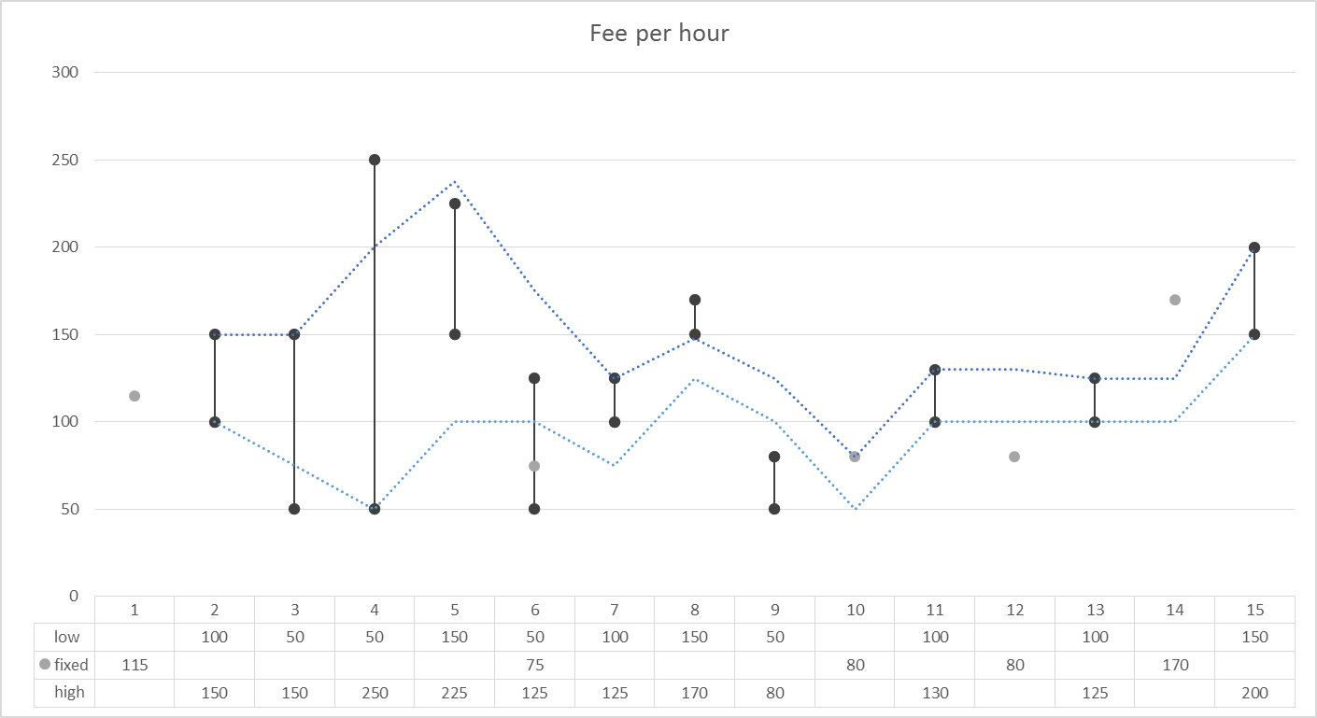

1. **What are some of the factors that impact the total fee?**

Size of non-profit organization, value of service, location (travel expenses), budget/ revenue of nonprofit, scope (workload), degree in complexity, evaluation of how easy or hard working with the organization will be, lengths of project, level of expertise of engaged consultant.

1. **What are typical deliverables for each consulting project type?**

|  |  |
| --- | --- |
| ESC Service | Deliverables |
| Facilitation | Flipchart, list of agreed action items, review of client write up, final report |
| Mentoring / Coaching | Improved performance of mentee; Guideline handbook, learning milestones |
| Strategic Planning | Strategic Plan, action plan, financial plan, mid-term report, evaluation report, Data plan, board presentation |
| Business / Operations Planning | Analytical findings, action plan, implementation plan |
| Governance | Implementation plan, action plan |
| Fundraising | Fundraising plan (action plan) with mentoring, appeal letter, case statement, materials for email campaign, planning of event, thank you letter, welcome letter, communication calendar, donor specialized strategy, donor persona statement, relationship building plan |
| Marketing & Brand Development | Marketing Plan, brand blueprint (int./ext. language), social media strategy |

**Summary findings:**

* The fee calculation is often based on estimated hours which leads to a flat project fee.
* The greater the amounts of projects per year, the lower is the hourly rate.
* Consultants with a more experience tend to spend more time on projects.
* Consultants with more experience have generally a higher fee.
* Most of the consultants hire supporting staff only when working on big and complex projects
* ESC is for some consultants a well-known competitor, so they were not willing to share a lot of information.

**Summary of all interviews as an overview:**

The overview of all interview data illustrates the name of the consulting organization and their specific answers. An average and median is calculated for the projects per year, the pricing, the number of staff and the years of experience. ‘TDC’ is not included in the calculation of the average numbers because it’s an outlier with its organization size and number of staff and would distort representative data.

The lengths of the different project types are statistically not comparable due to the various units of hours, months and years. However, a certain trend is still applicable.



**Internal Analysis:**

For the internal analysis of ESC of New England the financial years 2014-2016 were evaluated with special attention to previously charged fees. The Excel Sheets ‘Stage3 clients $ Fees by Project FY’xx” were used and combined to one table. The following calculations are all created with Pivot tools.

The following chart illustrates the **charged fees of FY14-16 according to the specific type of project:**



Within the FY14-16 most of the ESC Projects were Strategic Planning (31%), it also consists of the biggest range of fees, from $1,200 to $40,000.

55% of the projects are based on Strategic Planning (31%), Coaching (12%) and Fundraising (11%).

**Comparison of Financial Years:**

|  |  |  |  |  |
| --- | --- | --- | --- | --- |
| Financial Year | 2016 | 2015 | 2014 | 2014-2016 |
| Number of Projects | 71 | 102 | 60 | 233 |
| Fee (Average) | $6,072 | $6,203 | $6,025 | $6,118 |
| Fee (Median) | $4,250 | $4,000 | $3,500 | $4,000 |
| Budget Size of Clients (Average) | $24,208,505 | $3,399,948 | $4,223,206 | $11,084,273 |
| Budget Size of Clients (Median) | $1,465,540 | $841,531 | $614,393 | $909,448 |

To get a deeper insight into the data, please see the excel sheet “Fees & Clients FY14-16”. In this document, a Pivot tool is created with the possibility to select specifically between the variables:

* FY Year
* Project Type
* Budget Size
* Project (Client)
* Charged Fee

Excel Document:

The analysis of the **client budget structure per project** and the **sum of fee per budget category** is illustrated in the following: (FY ’14-’16)

* 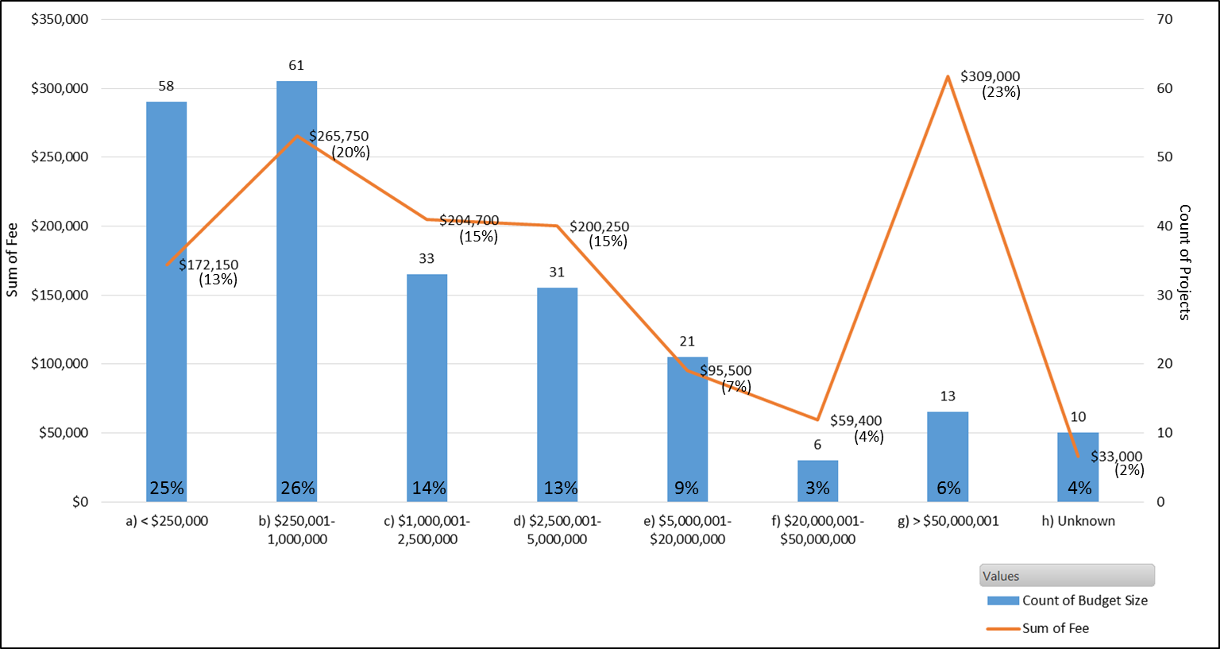51% of projects within the last three years were from clients with a Budget ≤ 1m
* 23% ($309,000) of total charged fee is made with clients with a Budget > 50m
* **ESC made 23% of its ‘revenue’ with 6% of its projects**

**Pricing Model:**

**Old Version:**

The old pricing model which was issued in June 2006, is based on a range calculated on the estimated hours and consultants per project. In the following table, the calculation is illustrated in the example of fundraising. The old pricing model is based on a standard rate of $500 per day which results in **$62.50 per hour** (assumption: 8 hours per day). The calculated minimum and maximum fee is used with the “multiplier 1” for clients with a revenue of 1,000,001 – 2,500,000.

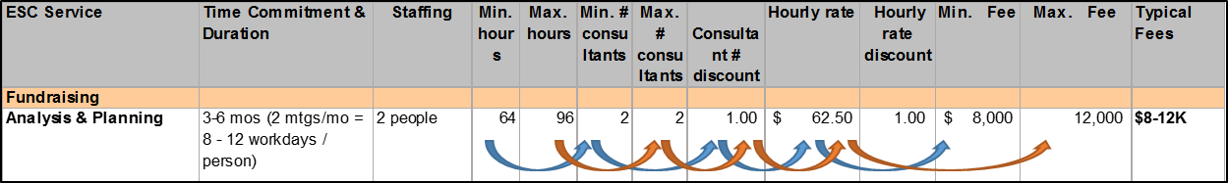

Due to the calculated range, a possible fee was estimated and adjusted to the different sizes of revenues with a multiplier. 

**New Version:**

The new pricing model consists on the same calculation theory than the old one. Due to our external market research result with an average hourly rate of $122.22, we considered it as a competitive and necessary change to increase the fee for the new model. The assumed standard fee for “multiplier 1” will change to the base of **$125 per hour** to calculate the range for every project type. A lower and a higher range is given for every revenue category, based on the initial calculated range and the specific multipliers. Additionally, we reevaluated the hours which every consultant would spend on every type of project, as well as how many people are typically members of the consulting teams. We also looked at what fees had been previously charged for each project and budget category. All of these factors contribute to the development of this new pricing model.

**Calculation matrix with project type assumptions and deliverables:**



In addition to the pricing model, a matrix which considers the estimated months of the project, the hours per week, and the rate per hour, is build:



**New Pricing Model:**

